Establishing a Multi-Thesauri-Scenario based on SKOS and Cross-Concordances

Philipp Mayr  GESIS – Leibniz Institute for the Social Sciences, Germany  philipp.mayr@gesis.org | Benjamin Zapilko  GESIS – Leibniz Institute for the Social Sciences, Germany  benjamin.zapilko@gesis.org | York Sure  GESIS – Leibniz Institute for the Social Sciences, Germany  york.sure@gesis.org

Keywords: SKOS; thesauri; cross-concordances; interoperability; Linked Open Data

1. Introduction
With the standardization of SKOS (Simple Knowledge Organization System) in August 2009 a data model has been offered to publish controlled vocabularies and taxonomies on the web in a technical and semantically interoperable way. The heterogeneous environment of various vocabularies worldwide can be harmonized prospectively and especially the content of traditional databases can be made accessible and connectable for applications of the Semantic Web, i.e. as Linked Open Data. Vocabularies in SKOS format can play a relevant role in this context, because they can serve as a bridging hub for the inter-linking of different published and indexed data sets.
This case study proposes a scenario with three topic-related thesauri, which have been connected with bilateral cross-concordances as part of a major terminology mapping initiative in the project KoMoHe (Mayr et al., 2008). The thesauri have already been or will be converted to SKOS and in order to not omit the relevant crosswalks, the mapping properties of SKOS will be used for modeling them adequately. The participating thesauri in this approach are: (i) TheSoz (Thesaurus for the Social Sciences, GESIS) which has been converted to SKOS in a first experimental version (Zapilko et al., 2009), an update is underway which will be oriented on the introduced SKOS extensions of the EUROVOC thesaurus (Smedt, 2009) and will use SKOS-XL additionally, (ii) STW (Standard-Thesaurus for Economics, ZBW) which has also been published in SKOS format (Neubert, 2009) and (iii) IBLK-Thesaurus (SWP).
Currently, the conversion of vocabularies to SKOS is an active research area, but there are still unsolved and relevant issues which could not be treated satisfyingly yet. Our approach focuses on the application of existing crosswalks to the SKOS mapping properties and the establishment of a linked data application based on those connected thesauri.

2. Modeling Cross-Concordances in SKOS
The SKOS mapping properties provide standardized relations in order to link SKOS concepts of different concept schemes, which are represented in this scenario by three participating thesauri. When modeling cross-concordances in SKOS format inconsistencies and problems can occur which are caused by idiosyncrasies in thesauri. Although SKOS provides a standard model for representing vocabularies, transformed or converted thesauri can differ a lot due to various complexity and heterogeneous structure. Modeling mostly term-based thesauri in a concept-based way can be realized differently. A reason for inconsistencies is that the given cross-concordances where defined on term-based thesauri, but the SKOS versions of those thesauri are concept-based. Therefore crosswalks between traditional thesauri cannot simply be adapted to the SKOS mapping properties. It has to be proven if the two terms of a given crosswalk represent adequate concepts in the corresponding SKOS versions by i.e. being used as skos:prefLabel (see figure 1). Generally existing cross-concordances have to be transformed to concept-based and therefore SKOS-compatible crosswalks.

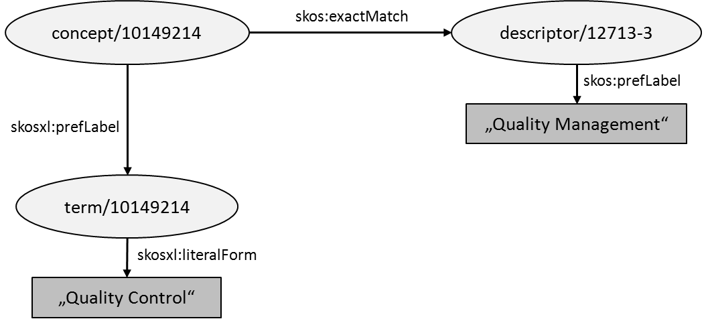

FIG. 1. Example: Abstract Mapping between TheSoz and STW.

Due to domain-specific differences in thesauri there exist cross-concordances which cannot be modeled within the current SKOS mapping properties adequately. For example, a concept in one thesaurus can correspond to a combination of two concepts in another thesaurus. The mapping properties of SKOS are too restrictive in their current definition that alternative possibilities have to be found how to deal with these special use cases.

3. Establishing a Multi-Thesauri-Scenario as a Linked Data Application
In order to provide interoperability between the participating thesauri and the external data sets, the thesauri and the cross-concordances between them have to be made accessible on the web. The most common way is to publish them via multiple SPARQL endpoints according to assumed physically different storage locations (thesauri of different organizations). A linked data interface, i.e. the Pubby frontend, is set upon these endpoints to generate a linked html representation of the different thesauri via dereferencing URIs. With the inclusion of crosswalks a stronger interlinking between the thesauri is represented which is not only based on a term or lexical level, but also on precise mappings between the concepts.

4. Conclusion and Further Research
The proposed case study outlines the potential of thesauri, which are bi-directional connected via cross-concordances, to serve as a bridge for a stronger interlinking of data sets on the web, i.e. Linked Open Data. Transforming existing vocabularies and thesauri to SKOS remains a complex issue according to the heterogeneous structure of the involved vocabulary. Especially the modeling of given crosswalks which have a term-based origin bears major problems when trying to transfer them to SKOS mapping properties and therefore to a concept-based representation.
One of the next steps in establishing such a proposed multi-thesauri-scenario is the technical implementation as a test application. Furthermore a generic method has to be developed on how to convert existing cross-concordances to SKOS with a minimal effort in intellectual post-processing.

References
Mayr, Philipp, Vivien Petras. (2008). Building a terminology network for search: the KoMoHe project. In Jane Greenberg & Wolfgang Klas (Eds.), Metadata for semantic and social applications: Proceedings of the 8. International Conference on Dublin Core and Metadata Applications, 2008, 177-182. Berlin: Uni.-Verl. Göttingen. from http://edoc.hu-berlin.de/docviews/abstract.php?lang=ger&id=29148
Neubert, Joachim. (2009). Bringing the "Thesaurus for Economics" on to the Web of Linked Data. Linked Data on the Web (LDOW2009). from http://events.linkeddata.org/ldow2009/papers/ldow2009_paper7.pdf
Smedt, Johan De. (2009). SKOS Extensions for the EUROVOC Thesaurus. 3rd Annual European Semantic Technology Conference.
Zapilko, Benjamin, York Sure. (2009). Converting the TheSoz to SKOS. GESIS Technical Report 2009/07. GESIS - Leibniz Institute for the Social Sciences. from http://www.gesis.org/fileadmin/upload/forschung/publikationen/gesis_reihen/gesis_methodenberichte/2009/TechnicalReport_09_07.pdf

http://www.w3.org/2004/02/skos/
http://linkeddata.org/
http://www.w3.org/TR/rdf-sparql-query/
http://www4.wiwiss.fu-berlin.de/pubby/

